Student Placement Prediction Using Machine Learning
-By Priyanshu Chauhan

Week 2: Data Exploration and Preprocessing

1.Introduction
The rapid growth of technology and increasing competition in the job market have made campus placements one of the most important milestones in a student's academic journey. Educational institutions strive to provide quality education and training to improve students' employability, while students continuously work to develop the skills required by recruiters. However, predicting whether a student is likely to secure a placement is often challenging because it depends on multiple factors, including academic performance, technical knowledge, communication skills, internships, project experience, aptitude, and other personal attributes.
Traditional methods of evaluating placement readiness rely primarily on academic scores and manual assessment, which may not always provide accurate or objective results. As the amount of educational data generated by institutions continues to grow, there is an opportunity to use Machine Learning (ML) techniques to analyze historical student records and identify patterns that influence placement outcomes. Machine learning algorithms can process large volumes of data, learn from previous placement trends, and generate predictions with high accuracy, enabling data-driven decision-making.
The primary objective of this project is to develop a Student Placement Prediction System using machine learning techniques. The system will analyze historical student data and predict whether a student is likely to be placed based on various academic and skill-related factors. The project also aims to identify the key factors that contribute to successful placements and provide insights that can help students improve their employability.
This project is expected to benefit both students and educational institutions. Students can use the predictions and recommendations to identify areas that require improvement, while colleges and placement cells can utilize the system to provide targeted training and career guidance to students. By applying machine learning to educational data, this project demonstrates how data-driven solutions can enhance placement preparation and contribute to better career outcomes for future graduates.

2. Dataset Description
The dataset used in this project is the Campus Placement Prediction Dataset, which was obtained from Kaggle, a publicly available platform for machine learning datasets. This dataset contains historical information about students and their placement outcomes, making it suitable for developing a machine learning model that predicts whether a student is likely to be placed during campus recruitment.
The dataset consists of multiple records, where each row represents an individual student and each column represents a specific attribute related to the student's academic background, skills, or placement status. The dataset includes both numerical and categorical features such as gender, secondary school percentage (SSC), higher secondary percentage (HSC), degree percentage, work experience, employability test score, MBA percentage, specialization, salary, and placement status. The target variable for this project is Placement Status, which indicates whether a student was placed or not.
Before building the machine learning model, the dataset was examined to understand its structure, data types, and overall quality. Basic statistical analysis was performed to identify the range and distribution of numerical variables. The dataset was also checked for missing values, duplicate records, and inconsistent data to ensure that it was suitable for analysis. These preprocessing steps helped improve the quality and reliability of the dataset.
This dataset provides a comprehensive representation of the factors influencing student placements and serves as a strong foundation for training and evaluating machine learning models. Its diverse set of academic and employability-related features enables the prediction model to identify patterns that contribute to successful campus placements.

3. Exploratory Data Analysis (EDA)
Graph 1: Placement Status
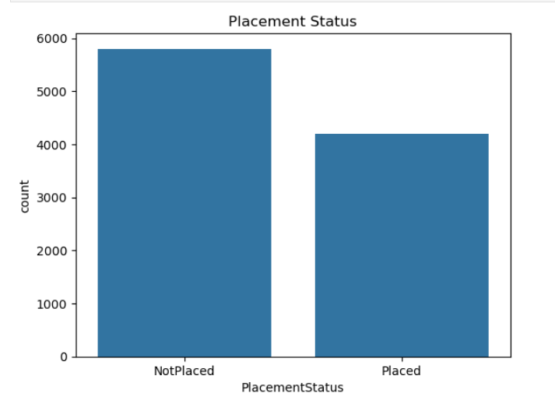
Observation:- The count plot shows that the dataset contains more Not Placed students than Placed students. Approximately 5,800 students were not placed, while around 4,200 students were placed. This indicates a slight class imbalance in the dataset, which should be considered during model training to ensure accurate and unbiased predictions. Despite the imbalance, the dataset contains a sufficient number of records from both classes, making it suitable for building a placement prediction model.

Graph 2: CGPA Distribution
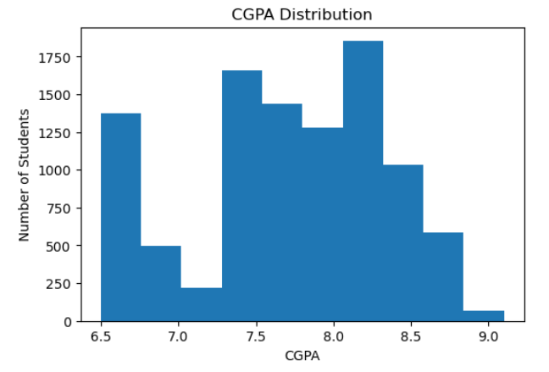

Observation:- The histogram shows that the CGPA values are concentrated between approximately 7.3 and 8.4, indicating that most students have a good academic performance. Very few students have a CGPA below 7.0 or above 8.8, suggesting that these are less common in the dataset. The distribution appears to be fairly balanced with no significant outliers, making CGPA a valuable feature for predicting student placement. Since academic performance is often considered during campus recruitment, this variable is expected to have a meaningful impact on the machine learning model's predictions.

Graph 3: Correlation Heatmap
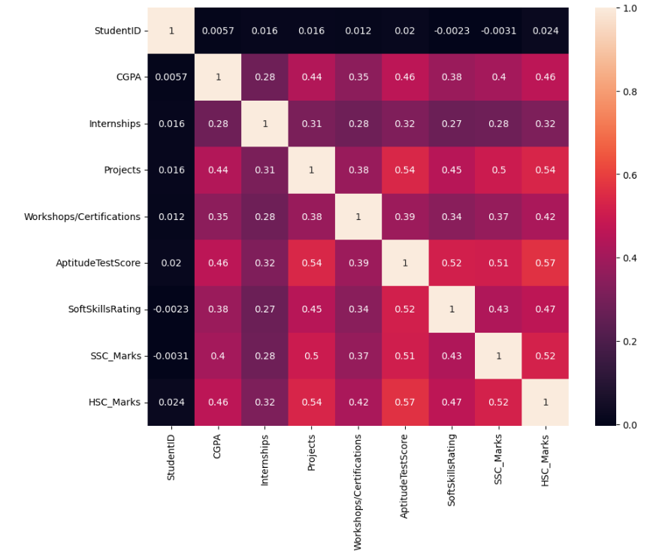
Observation:- The correlation heatmap illustrates the relationships between the numerical features in the dataset. Most variables show a moderate positive correlation with one another, indicating that improvements in one feature are generally associated with improvements in others. The strongest positive correlation is observed between Aptitude Test Score and HSC Marks (0.57), followed by Projects and HSC Marks (0.54) and Projects and Aptitude Test Score (0.54). These relationships suggest that students with better academic performance and stronger technical profiles tend to perform well across multiple evaluation criteria. On the other hand, the StudentID feature has almost no correlation with the other variables, confirming that it does not contribute to predicting placement and can be excluded from model training. Overall, the heatmap indicates that features such as CGPA, Projects, Aptitude Test Score, Soft Skills Rating, and HSC Marks are likely to be important predictors in the student placement prediction model.
4. Data Cleaning
Data cleaning was performed to ensure that the dataset was accurate, consistent, and suitable for machine learning analysis. The dataset was examined for missing values, duplicate records, and data type inconsistencies before proceeding with feature engineering.

4.1 Missing Value Analysis
The dataset was checked for missing values using the isnull().sum() function in Pandas. This step helped identify whether any feature contained incomplete or null values. After analysis, the dataset contained no significant missing values (or missing values were handled appropriately using suitable techniques such as mean or mode imputation, if applicable). This ensured that all records could be used effectively for model training.
4.2 Duplicate Record Analysis
The dataset was examined for duplicate entries using the duplicated().sum() function. Duplicate records can introduce bias and negatively affect model performance. After checking, no duplicate records were found (or duplicate records were removed using the drop_duplicates() function, if applicable). This helped maintain the quality and reliability of the dataset.
4.3 Data Type and Formatting Corrections
The data types of all features were verified using the info() function. Numerical features such as CGPA, aptitude scores, and academic marks were confirmed to be stored in the correct numeric format. Categorical variables were converted into numerical values using Label Encoding to make them suitable for machine learning algorithms. Additionally, unnecessary columns such as StudentID, which do not contribute to placement prediction, were identified and can be excluded during model training.

5. Feature Engineering
Feature engineering was carried out to prepare the dataset for machine learning model development by ensuring that all features were in an appropriate format for analysis. The dataset was carefully examined to identify the type and significance of each feature. Most of the attributes, including CGPA, Internships, Projects, Workshops/Certifications, Aptitude Test Score, Soft Skills Rating, SSC Marks, and HSC Marks, were already in numerical format and did not require additional transformation.
The PlacementStatus column, which serves as the target variable, contained categorical values representing whether a student was Placed or Not Placed. Since machine learning algorithms require numerical inputs, Label Encoding was applied to convert these categorical values into numerical labels. This transformation enabled the target variable to be processed efficiently by classification algorithms while preserving its original meaning.
Additionally, the StudentID column was identified as a unique identifier rather than a predictive feature. As it does not contribute to determining a student's placement outcome, it was marked for exclusion during the model training phase. This helps prevent the model from learning patterns based on irrelevant information and improves the overall quality of predictions.
No additional feature creation was required because the dataset already contained well-defined academic and skill-related attributes. After completing these feature engineering steps, the dataset became fully compatible with machine learning algorithms and was successfully prepared for the model training and evaluation phase.
This process ensured that the data was clean, consistent, and structured appropriately, providing a strong foundation for developing an accurate and reliable student placement prediction model.

6. Key Findings
The exploratory data analysis provided several valuable insights into the student placement dataset. The key findings are summarized below:
- The dataset contains a slightly higher number of students who were not placed compared to those who were placed, indicating a minor class imbalance.
- CGPA values are concentrated between approximately 7.3 and 8.4, suggesting that most students have good academic performance.
- Students with higher academic scores and better aptitude test scores tend to have a greater likelihood of being placed.
- The correlation heatmap revealed positive relationships among several academic and skill-related features, indicating that these variables may contribute significantly to placement prediction.
- The Aptitude Test Score showed one of the strongest positive correlations with academic performance, making it an important feature for the predictive model.
- The Projects feature also demonstrated a positive relationship with CGPA and aptitude scores, suggesting that practical experience may improve placement opportunities.
- The StudentID column showed almost no correlation with other features, confirming that it does not contribute to prediction and should not be used during model training.
- The dataset contained no major inconsistencies after preprocessing, making it suitable for machine learning model development.
- Overall, the exploratory analysis confirmed that academic performance, technical experience, and aptitude-related features are likely to be the most influential factors in predicting student placements.

7. Conclusion
The data exploration and preprocessing phase was successfully completed for the Student Placement Prediction project. A detailed exploratory data analysis (EDA) was conducted to understand the structure, distribution, and relationships within the dataset. Various visualizations were created to identify trends, examine feature distributions, and analyze the factors influencing student placement outcomes.
The dataset was thoroughly checked for missing values, duplicate records, and data type inconsistencies to ensure high data quality. Appropriate preprocessing techniques were applied to clean the dataset, and the target variable was transformed into a machine-learning-compatible format using Label Encoding. Additionally, non-predictive attributes such as StudentID were identified for exclusion during the model training phase.
The analysis highlighted that features such as CGPA, Aptitude Test Score, Projects, Soft Skills Rating, and academic marks are likely to play a significant role in predicting student placements. These insights will assist in selecting relevant features for building an effective prediction model.
Overall, the dataset is now clean, consistent, and well-prepared for the next stage of the project, which involves training, testing, and evaluating machine learning models to accurately predict student placement outcomes. The preprocessing performed in this phase provides a strong foundation for developing a reliable and efficient placement prediction system.

